1. Agenda:
   1. What is a certificate Domain Scope and which domains exist.
2. 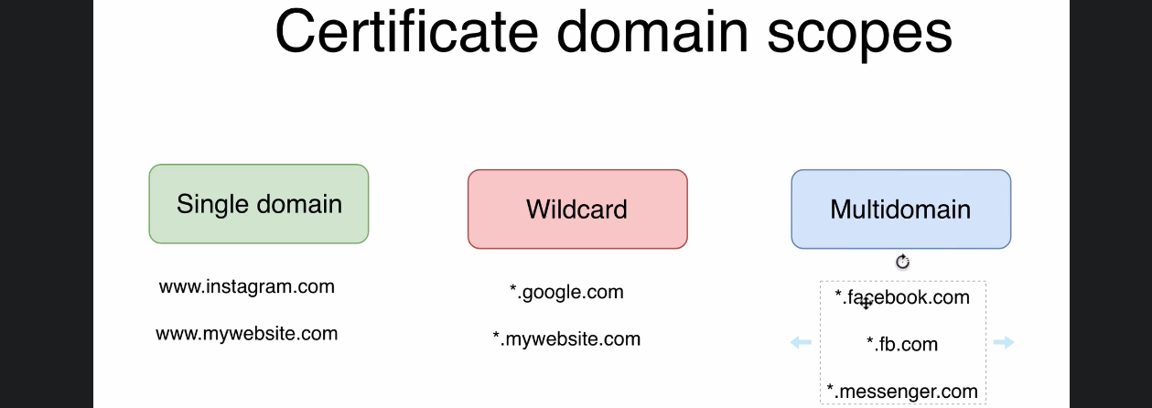
3. First Type of Certificate Domain Scope is Single Domain Scope.
   1. Such certificates can be used only at a single Domain.
   2. CA Property value in such certificate is equal to the domain.  
      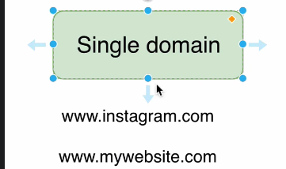
4. Next Category of Wild Card Certificates:
   1. CA Property value is like this  
      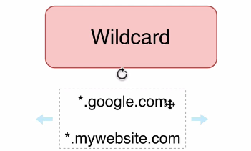
   2. Such certificate can be used on sub-domain level.
5. **Another Scope for Certificates is Multidomain**:  
   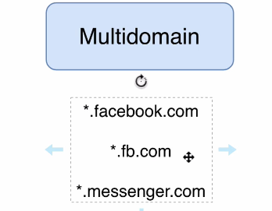  
   This is much wider scope as such certificates can be used on multi domains, sub-domains.
6. Single Domain Certificate is cheaper whereas multi-domains are much expensive.